**Express Middleware**

**Express.js** is a routing and Middleware framework for handling the different routing of the webpage and it works between the request and response cycle. Middleware gets executed after the server receives the request and before the controller actions send the response. Middleware has the access to the request object, responses object, and next, it can process the request before the server send a response.

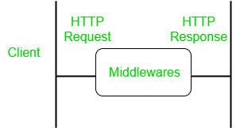

An Express-based application is a series of middleware function calls.

**Advantages of using middleware:**

* Middleware can process request objects multiple times before the server works for that request.
* Middleware can be used to add logging and authentication functionality.
* Middleware improves client-side rendering performance.
* Middleware is used for setting some specific HTTP headers.
* Middleware helps for Optimization and better performance.

**Middleware Chaining:** Middleware can be chained from one to another, Hence creating a chain of functions that are executed in order. The last function sends the response back to the browser. So, before sending the response back to the browser the different middleware process the request.

The [next()](https://www.geeksforgeeks.org/what-is-the-use-of-next-function-in-express-js/) function in the express is responsible for calling the next middleware function if there is one.

**Modified requests will be available to each middleware via the next function –**

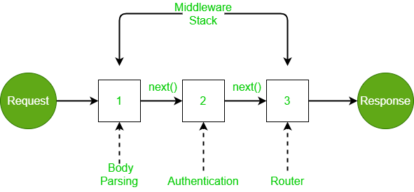

***Middleware chaining example***

In this case, the incoming request is modified and various operations are performed using several middlewares, and middleware is chained using the next function. The router sends the response back to the browser.

**Below is example to understand concept of middleware.**

var express = require("express");

var app = express();

**//Method 1**

const **fun1**=(req,res,**next**)=>

{

    res.set("content-type","text/html")

    res.write("<h1>First</h1>");

**next();**

}

const **fun2**=(req,res,**next**)=>

{

    res.write("<p>Addition = " + (5+5) + "</p>");

**next();**

}

**app.use("/test",cb,cb1);**

app.get("**/test**",(req,res)=>

{

    res.write("<h3>Hello Welcome to LJU</h3>");

    res.send();

});

app.listen(6002)

**//Method 2**

var express = require("express");

var app = express();

app.use(

    "**/xyz**",

    (req, res, **next**) => {

      console.log("request received on"+new Date());

**next();**

    },

    (req, res, **next**) => {

        res.set("content-type","text/html")

        res.write("<h3>Hello</h3>");

**next();**

      },

    (req, res) => {

      res.write(`<h5>Tutorial on Middleware</h5>`);

    res.send();

    }

  );

app.listen(6001)